Sexism in Mexican American Music By Angela Santana
As a woman, I believe it is our right to have the same recognition and opportunities as men. Women have always pushed for equal rights and opportunities and we have yet to achieve it. We constantly see men as the majority including in music. Men have always been the top priority in the music industry and it is time for change. Women are treated very differently and are often sexually harassed in the music industry. A man will never know how much harder women have to work in order to accomplish their goals.
Sexism in the music industry not only exists in the United States, but many other places as well. In Mexico it is very rare to come across a successful Female singer, women are not often featured in broadcasting networks. Mexico does have its cultural issues with women, and therefore this may be a representation of it. The U.S has a huge problem in victimizing women and often ignoring the real issues at hand. The United States simply puts the blame on women when they are not at fault. We often see women sexualized in music videos even when the song has nothing to do with the female body or a female in general. These types of videos send out the wrong message to viewers making them think it is okay to treat women as objects for men to look at or use for pleasure, women are human beings who deserve to be treated equally and obtain the same rights as men.
Mexican culture revolves around men as the breadwinners, woman as homemakers, and the United States is just the same. However, the United States is slowly changing, women are becoming more present in areas where men have been dominate. We can see this through the presence of women in music in Mexico and the United States. In Mexico there are specific genres that are more popular in certain places. Where my family comes from we often only listen to banda which is a genre that contains a group or band that performs with wind instruments. This specific genre is almost only promoted by male groups or male singers. There are female singers who sing banda, but they are not as promoted or shown the same respect as an artist. Fabi Reyna, author of the article The Women of Mariachi: Breaking Barriers in a Machismo Culture explains how women are still finding ways to tear down traditional sexism: “In recent years women’s presence in mariachi has become more common, and in 2014 there were about 30 all-female mariachi groups in the United States, 60 in Mexico, South America and Canada, and even one in England” (1). Although, the numbers were very low; progress is being made. In the United States women have a bit more freedom, but still are not as recognized as they should be. Amy Zimmerman perfectly illustrates what it is like for women in the music industry with her article Female Artists Speak Out Against Music Industry Sexism at SXSW: “While this is hardly an anomaly—according to one report, only 9.3 percent of Grammy nominees in the last six years were women—women in a post-Weinstein world had run out of patience for this brand of inexcusable inequity. In response to the backlash Neil Portnow, the president of the Recording Academy, told reporters that women need to “step up” in order to claim an influential position in the industry” (1). Due to this incident many people have began to protest the Grammys award show. Huge artists like Ariana Grande protested and decided not to attend even though she was a nominee. She ended up winning her first Grammy for Best Pop Album of the Year while she was not in attendance. (Fig.1)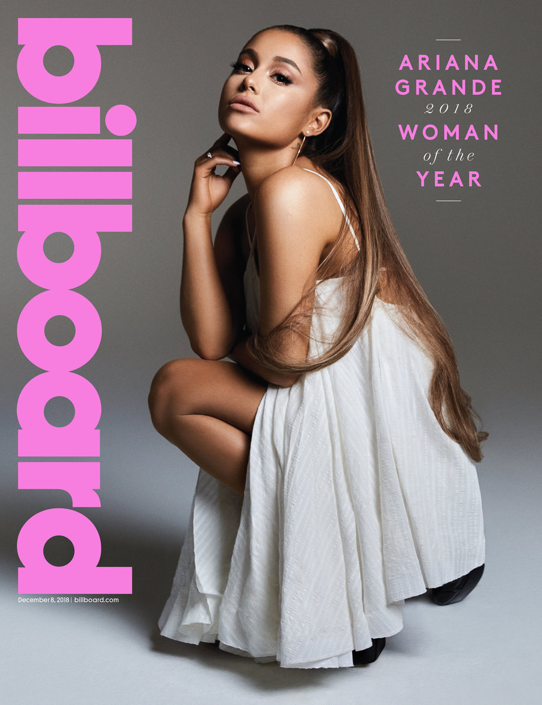Winning a Grammy and not attending because one believes they deserve so much more than what is being offered to them, is standing up for what they believe in and a call for change.
It is ridiculous that in the year 2019 women are still having to fight for rights, in the music industry they are fighting for the right to be heard. Growing up in a Mexican household I would always listen to mexican music, however, the only female singer that I ever listened to sing in spanish at the time was Selena Quintanilla. Selena Quintanilla is probably the only Mexican-American woman to be idolized in Mexico’s music Industry. For those who are not familiar with Selena Quintanilla, here is a brief summary of her life. Selena Quintanilla, also known as La Reina Del Tex Mex (the queen of tejano music) is one of the most influential woman in Mexican music. She is a grammy award winning artist with numerous hit singles. She specialized in singing cumbia, but also sang other genres as well. She was the first of many artists to cross over into English music. For those of you who are unfamiliar with Tejano music and Cumbia; Tejano music originated in Texas and was later introduced to Mexico, it is the “Country” music of Mexico; Cumbia originated in Columbia and made its way to Mexico, it is filled with a variety of drum beats. Selena’s influence on cumbia has left a huge mark in Mexico’s culture and continues to do so even after her death. (Fig. 2)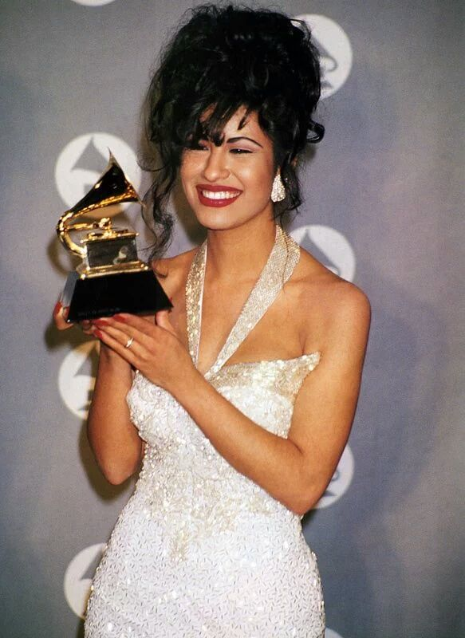Growing up, there were no other women that dominated the industry like Selena and she too had her setbacks. She too was sexualized especially because the majority of her audience was Mexican, Mexico is known for its machismo. It is a huge problem, and we are seeing more of it in the United States as well:
The three female singer-songwriters were tasked with navigating the under-discussed and endlessly complicated issue of #MeToo in the music industry, from sexual harassment and rampant misogyny to gender equity and subverting the male gaze. As the decisive backlash to Portnow’s comments proved, and as Lambert pointed out, the idea that women are responsible for their own lack of inclusion—or, by extension, responsible for dodging misogyny or evading sexual assault—is laughable. But in the face of a largely structureless industry where men hold the majority of the power and women are often devoid of recourse, legal or otherwise, women have had to take up the heavy burden of demanding equity in an industry that is built to keep them out (Zimmerman 1).

This is such a huge issue that needs to be brought up more. These women, who are idolized by young girls all over the world, have to go through so much just to be brought down by such a sexist agenda. It is only teaching young girls that they too have to go through multiple obstacles and be objectified based off of their sex. When in reality it is not normal for these things to be happening.
In this day and age we expect so much more from our society. We have fought for our rights and continue to prove that we are not just objects to be sexualized and harassed. We are human too, and we deserve the same opportunities and equal rights the way men have always been granted. The music industry and society as a whole needs to change, women should not have to work twice as hard as men to be given the same opportunity. We will not stop until our voices are heard.

